**Assignment –8 Formatting Query output.**

1. Assume each salesperson has a 12% commission. Write a query on the orders table that will produce the order number, the salesperson number, and the amount of the salesperson’s commission for that order.

**Select Onum, Snum , Amt*0.12 “Commision” from ORDERS;**

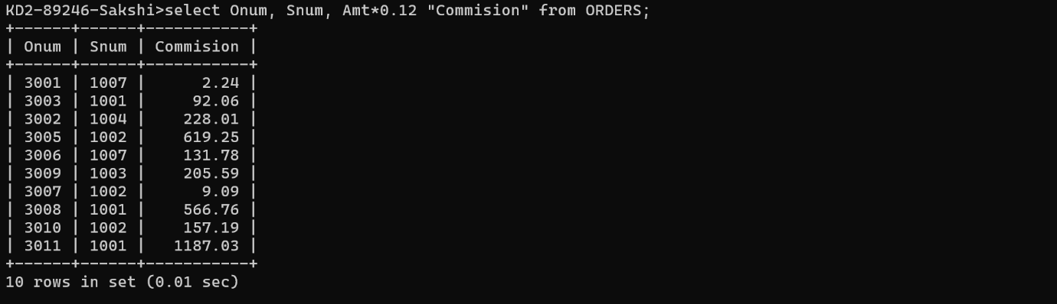

1. Write a query on the Customers table that will find the highest rating in each city. Put the output in this form: For the city (city), the highest rating is : (rating).

**Select concat(concat(“for the city” ,city), “the highest rating is “, max(Rating) )from Customers group by City;**

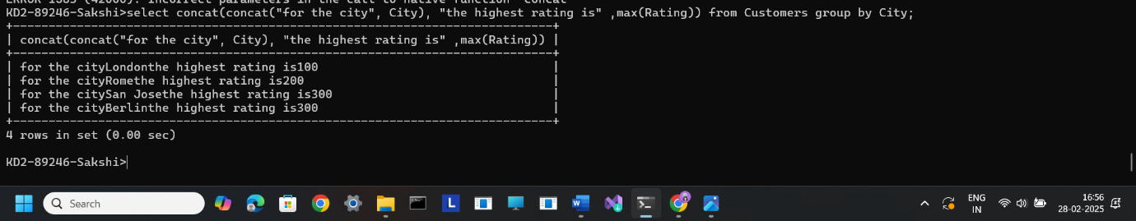

1. Write a query that lists customers in descending order of rating. Output the rating field first, followed by the customer’s name and number.

**Select * from Customers order by rating desc;**



4)Write a query that totals the orders for each day and places the results in descending order.

**Select odate, count(*) from orders group by Odate order by count(*) desc;**

